- 通道配置，选择相应串口，波特率9600，数据位8，停止位1，偶校验，完成后点击确认即可
1. Channel configuration, select the corresponding serial port, baud rate 9600, data bit 8, stop bit 1, even parity, click OK after completion.

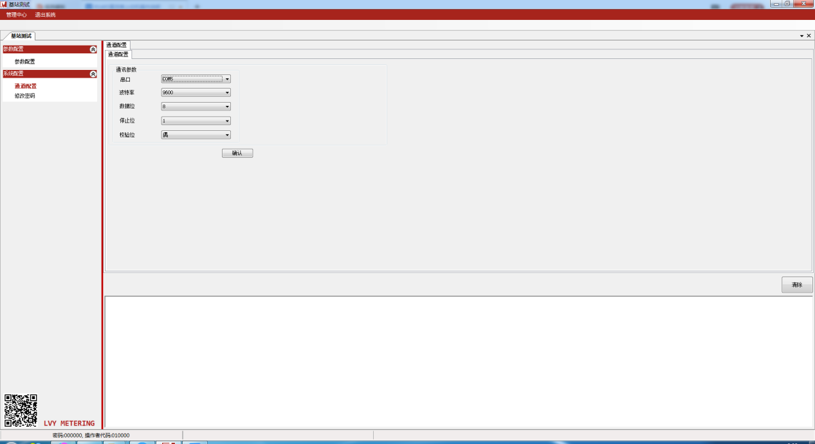

- 电表参数配置
2. Meter parameter configuration
  - 输入电表序列号（或者召读通讯地址）
2.1 Enter the serial number of the meter (or the address of the call-reading communication)

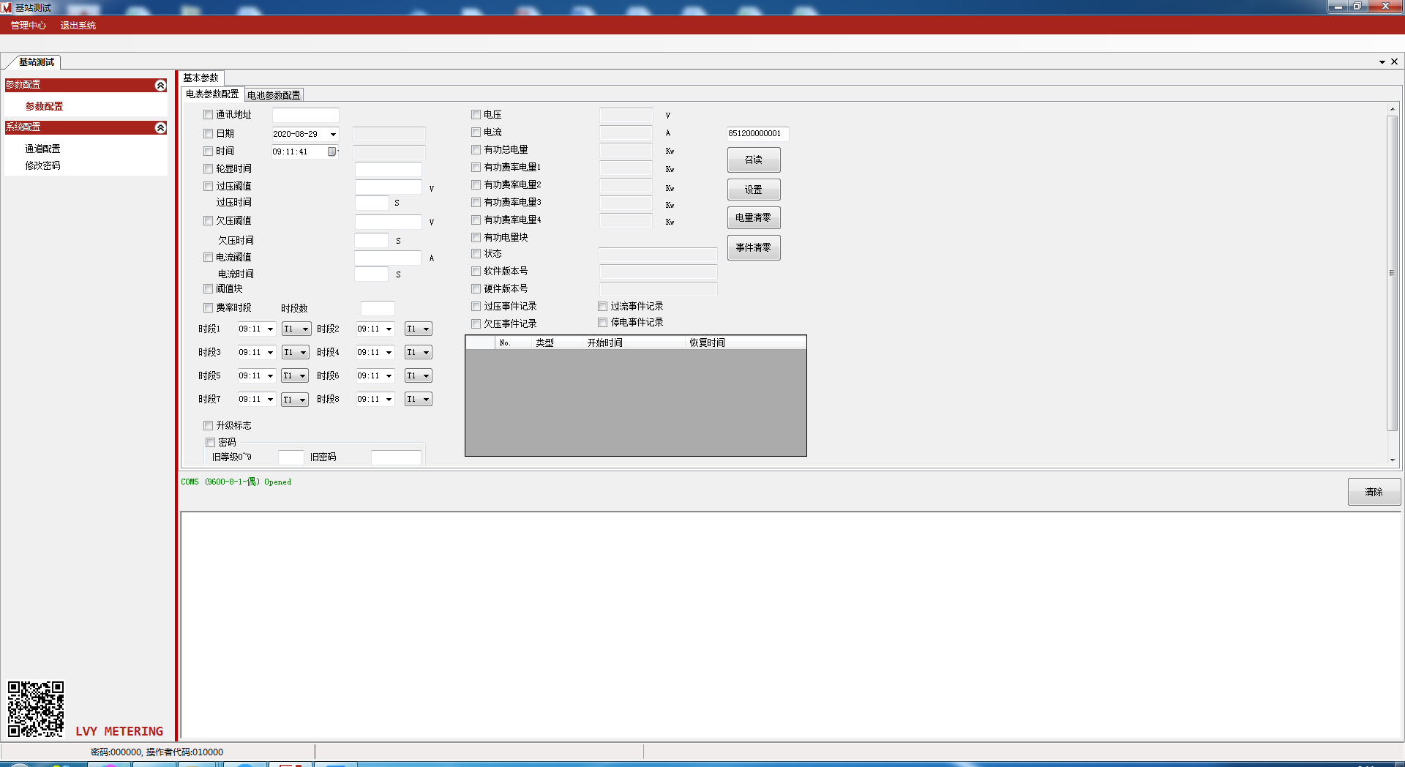

2.2显示序列号后，可对其他参数召读和设置。
2.2 After the serial number is displayed, other parameters can be read and set.

